SASS & BIDE X BARNARDOS AUSTRALIA
To every vulnerable child and family who needs support, and to the dedicated Barnardos staff who work each day to provide just that – we see your ‘heart of gold’ and wear ours as a symbol of love and gratitude.
THE STORY
Rocky Barnes and her 2 million followers offer their support to celebrate the sass & bide x Barnardos partnership for 2020.
This year sass & bide honour the heart and compassion of the Barnardos staff who work selflessly to bring safety and protection to those who need it most, with their limited-edition ‘Heart of Gold’ tee for adults and kids. To help raise vital funds, 100% of profits from every tee sold will go directly to of Barnardos Australia©.
The bond between a child and their Barnardos carer is an incredibly special and unique relationship, something sass & bide wanted to capture through the child’s eyes. Looking at the world through their eyes exposes unique perspectives. Part of this photo series was captured by the Barnardos children on digital and polaroid photography.
PARTNERSHIP
For over 15 years, sass & bide have proudly supported the incredible, life-changing work of Barnardos Australia©. Answering the call of vulnerable families and children in crisis, Barnardos provides care, support and essential services to disadvantaged communities deeply affected by violence, poverty, homelessness and mental illness.
AVAILABILITY
The limited-edition tees are available from Tuesday 14th July at sass & bide boutiques, sassandbide.com and participating Myer stores.
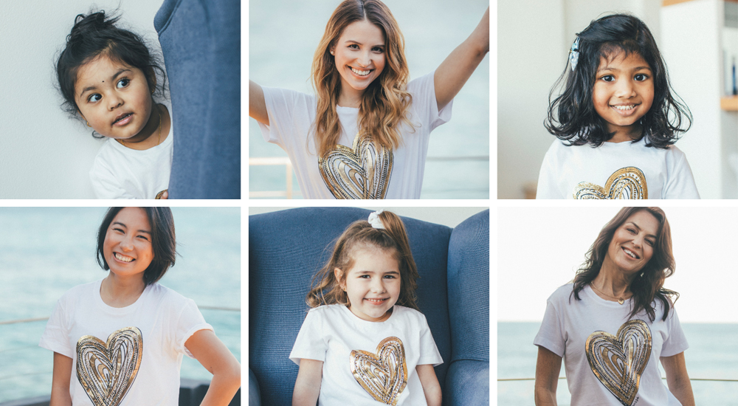
RRP $160 for the ‘Heart Of Gold’ (adults) & $90 for the ‘Heart Of Gold’ (kids) tees.
Link to www.sassandbide.com/barnardos-20

